Wang Zhang

csc560  ID:16156513

report of Lab 1

1. Snapshot of ER Diagrams and the Class diagram using Visio

(1). ER Diagram: **Suppose we wish to keep a genealogy. We shall have one entity set, Person. The information we wish to record about persons includes their name (an attribute) and the following relationships: mother, father, and children. Give an E/R diagram involving the Person entity set and all the relationships in which it is involved. Include relationships for mother, father, and children. Extend it with additional relationships such as husband and wife. Do not forget to indicate roles when an entity set is used more than once in a relationship.**

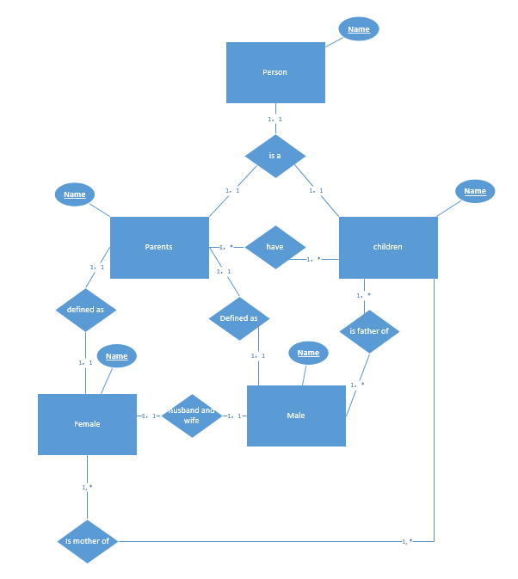

For ER diagram, start with person. Person can be define as parents and children, their relationship is 1 to 1. Parents may have more than one child and one child can only have one parents, so the relationship between parents and children is one to many. Parents can be define as female and male, their relationship is 1 to 1. Female and male relationship are husband and wife, female can only have one husband and male can only have one wife, therefore they are one to one relationship. Female is mother of the children and male is father of the children, they both may have more than one child, so they are 1 to many relationship.

**(2). Class Diagram: For the given domain (i.e., Family), define UML Class Diagram that specifies classes and their relationships with specific relationships such as inheritance, aggregation, composition, dependence, association, etc.**

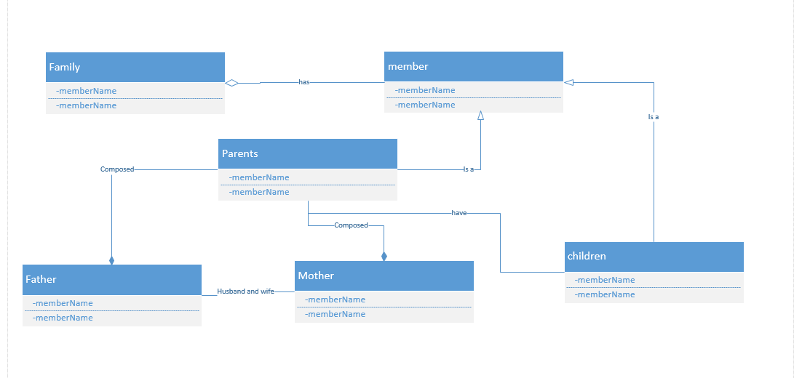

For class diagram, a family has member, so they are aggregation relationship. The member is define as parents and children, so they are inheritance relationship. Parents and children are association relationship. Parents composed father and mother, so they are composition relationship. Between father and mother, they are husband and wife, so they are association relationship.

(2). **Create a GitHub account:**

**Here is my GitHub account main page:**

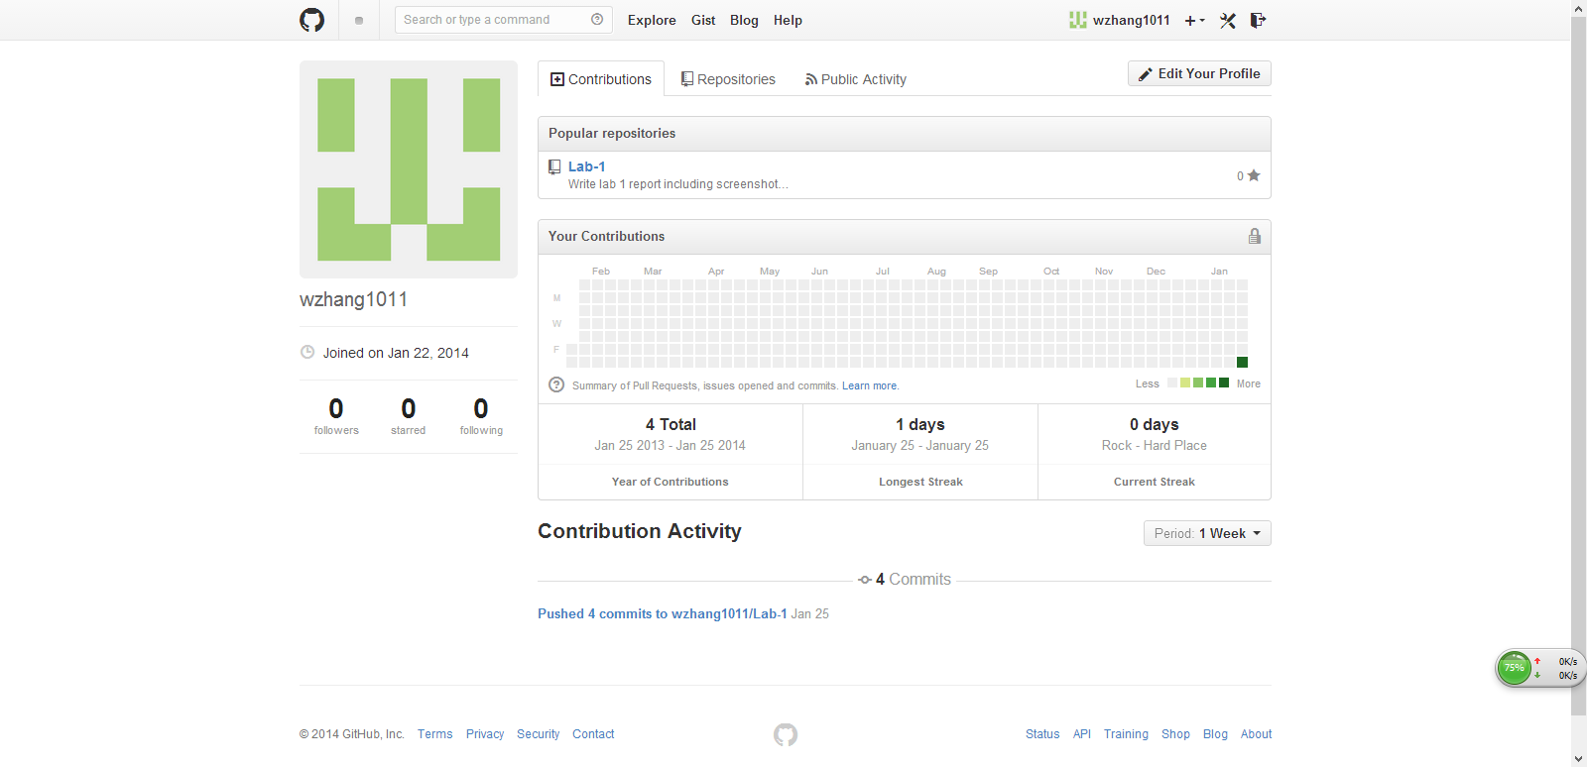

(3). **Create a ScrumDo account and define task/plan/delivery for your lab 1 assignment:**

**1. ScrumDo account main page:**

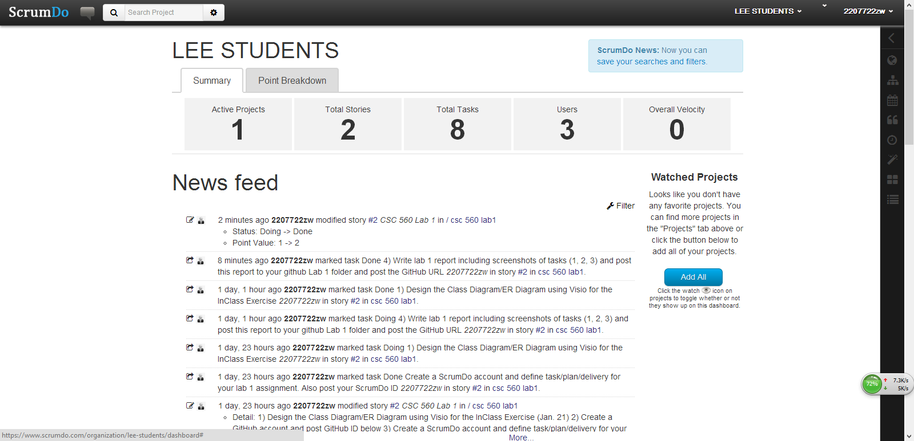

**2. Below is screenshot of 4 tasks for lab 1:**

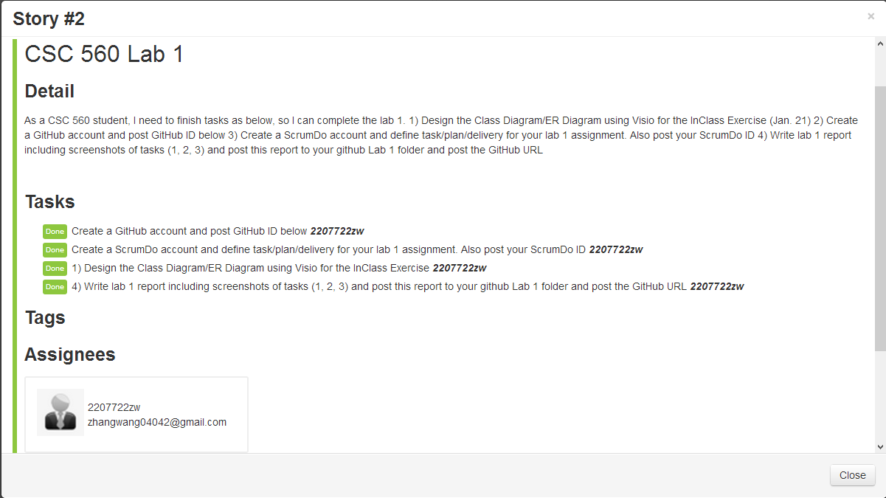

**3. Below is screenshot of plan for lab 1**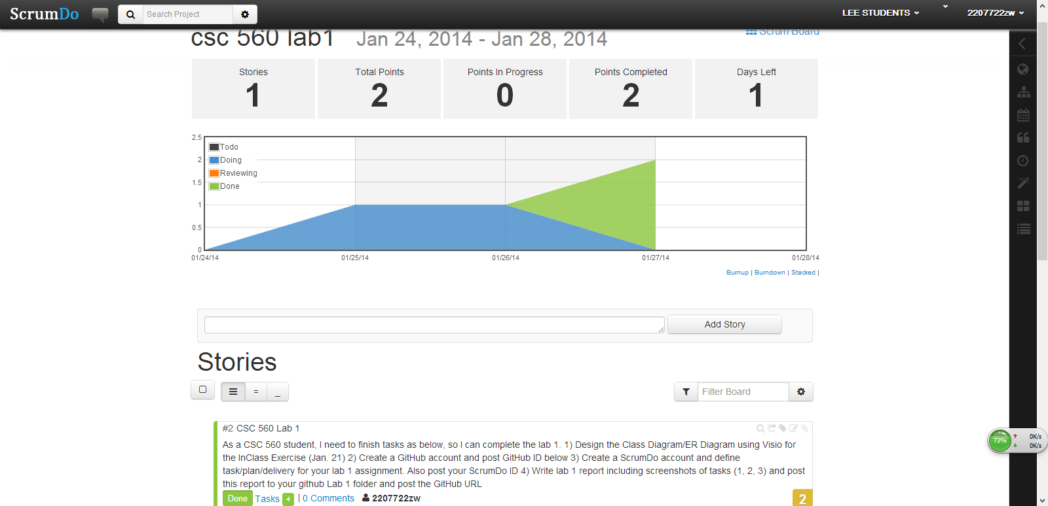

**4. below is delivery of the lab 1**

